A PROJECT REPORT

on

“Visa Processing System”

Submitted to

KIIT Deemed to be University

In Partial Fulfilment of the Requirement for the Award of

BACHELOR’S DEGREE IN

INFORMATION TECHNOLOGY

BY

Aniket Kumar Mishra
Ujjwal Singh
Abdul Wahid Aadil
ABHINAV PRAKASH
SIDDHARTH
Ankit Dev

2029187
2029193
2029194
2029042
2029214
2029195

UNDER THE GUIDANCE OF

- Neha



SCHOOL OF COMPUTER ENGINEERING

KALINGA INSTITUTE OF INDUSTRIAL TECHNOLOGY

BHUBANESWAR, ODISHA - 751024

May 2020

A PROJECT REPORT

on

“Visa Processing System”

Submitted to

KIIT Deemed to be University

In Partial Fulfilment of the Requirement for the Award of

BACHELOR’S DEGREE IN INFORMATION TECHNOLOGY

BY

Aniket Kumar Mishra
Ujjwal Singh
Abdul Wahid Aadil
ABHINAV PRAKASH
SIDDHARTH
Ankit Dev

2029187
2029193
2029194
2029042
2029214
2029195

UNDER THE GUIDANCE OF

B. Neha

SCHOOL OF COMPUTER ENGINEERING

KALINGA INSTITUTE OF INDUSTRIAL TECHNOLOGY

BHUBANESWAE, ODISHA -751024

May 2022

KIIT Deemed to be University

School of Computer Engineering
Bhubaneswar, ODISHA 751024

CERTIFICATE

This is certify that the project entitled

“NAME OF PROJECT“

submitted by

Aniket Kumar Mishra
Ujjwal Singh
Abdul Wahid Aadil
ABHINAV PRAKASH
SIDDHARTH
Ankit Dev

2029187
2029193
2029194
2029042
2029214
2029195

is a record of bonafide work carried out by them, in the partial fulfilment of the requirement for the award of Degree of Bachelor of Engineering (Computer Sci-ence & Engineering OR Information Technology) at KIIT Deemed to be university, Bhubaneswar. This work is done during year 2023-2024, under our guidance.

Date: 05/12 /2023

( B Neha)
Project Guide

Acknowledgements

We are profoundly grateful to B. Neha of Affiliation for her expert guidance and continuous encouragement throughout to see that this project rights its target since its commencement to its completion. .....................

Aniket Kumar Mishra(2029187)
Ujjwal Singh(2029193)
Abdul Wahid Aadil(2029194)
Abhinav Prakash(2029042)
Siddharth(2029214)
Ankit Dev(2029195)

ABSTRACT

The proposed "Visa Processing System" project is an automated system. It describes the visa application process. The government offers numerous visa types, such as the H1-visa and the Dependent visa. Obtaining a Visa, Visa issuance is a very objective and non-subjective decision. Every visa official has a list of requirements that applicants look for when applying for a visa. If they are met, the applicant will be granted the visa. Otherwise, the applicant does not qualify. It is the manner in which these requirements are met that gives the impression that a visa decision is subjective. The project's goal is to demonstrate how an online visa processing management system can be faster and more efficient than the current system. We have described in great detail the workflow and dataflow of a visa management system in this report. This project is an important component of a larger border management system that monitors the identity of travellers entering or residing in a specific country. This project will handle various types of visas and generate reports about the applicants to determine whether they are eligible for the visa or not.

Contents

1 | Introduction |  |  | 1
2 | Literature Review |  |  | 2
3 | Software Environment / Requirement Specifications |  |  | 4
 | 3.1 | Project Planning........................... |  | 4
 | 3.2 | Project Analysis (SRS)................. |  | 5
 | 3.3 | System Design ………………….. |  | 6
 |  | 3.3.1 | Design Constraints …… | 6
 |  | 3.3.2 | System Architecture (UML) / Block Diagram … | 7
4 | Implementation |  |  | 9
 | 4.1 | Methodology / Proposal ........................... |  | 9
 | 4.2 | Testing / Verification Plan ……………. |  | 10
 | 4.3 | Result Analysis / Screenshots …………. |  | 10
 | 4.4 | System Study …………………….. |  | 14
5 | Input and Output Design |  |  | 15
6 | Conclusion and Future Scope |  |  | 19
 | 6.1 | Conclusion ……………………….. |  | 19
 | 6.2 | Future Scope ………………………. |  | 19
References |  |  |  | 20
Individual Contribution |  |  |  | 21
Plagiarism Report |  |  |  | 25

Visa Processing System

Chapter 1 : Introduction

Visa Management is a vital facet of service-oriented applications, streamlining processes like visa application, information handling, and issuance. It stands as a cornerstone in fortifying security measures, enhancing efficiency, and notably, ensuring convenience throughout the entire procedure.
In our project, we've meticulously crafted various components for a comprehensive visa management system. These features are neatly categorized into three sections based on user roles and clearance levels:
1. HR Manager: The site administrator responsible for managing system executives, having full control to add, delete, and update HR executives.
2. HR Executive: Overseeing the applicant application process.
3. Applicant: Users/customers applying for visas.

Our system tailors features according to these user categories, delivering functionalities such as:
1. Visa Application: Facilitating the submission of applicant data through the portal.
2. Visa Status: Providing comprehensive reports on application status, whether accepted, rejected, or under processing.
3. Visa Renewal: Offering an application process for the renewal of existing visas.
4. Visa Enquiry: Establishing a customer service portal for addressing queries.
5. Assign HR Executive: A portal exclusively for HR managers to manage HR executive roles efficiently.
6. Report: Detailed status reports on applicant submissions.

School of Computer Engineering, KIIT, BBSR

Chapter 2 : Literature Review

The literature survey encompasses a range of significant research works revolving around recommender systems, particularly in the context of tourism and user preferences.

1) "e-Tourism: A tourist recommendation and planning application" by L. Sebastia, I. Garc´ıa, E. Onaindia, and C. Guzm´an Alvarez, introduces a comprehensive e-Tourism application that combines recommender and planning modules. The recommender system offers a list of city places based on user demographics, past trip preferences, and current visit choices. Subsequently, the planning module organizes these recommended places into a feasible agenda for users.

2) "Introduction to recommender systems handbook" by F. Ricci, L. Rokach, and B. Shapira acts as a foundational introduction to Recommender Systems (RSs). It delineates fundamental concepts and serves as a guide for navigating through the extensive content of the handbook.

3) "Toward the next generation of recommender systems: A survey of the state-of-the-art and possible extensions" by G. Adomavicius and A. Tuzhilin, provides an overview of current recommendation methods categorized into content-based, collaborative, and hybrid approaches. The paper discusses limitations of existing methods and proposes extensions to enhance recommendation capabilities, such as incorporating contextual information and supporting multi-criteria ratings.

4) "Semantics-aware content-based recommender systems" authored by M. de Gemmis, P. Lops, C. Musto, F. Narducci, and G. Semeraro, explores content-based recommender systems that consider the semantics within item descriptions. The paper identifies current limitations and proposes an improved architecture to build semantics-aware recommendations, focusing on disambiguating item descriptions to enhance recommendation accuracy.

5) "A tourism recommender system based on collaboration and text analysis" by S. Loh, F. Lorenzi, R. Salda˜na, and D. Lichtnow, presents a recommender system aiding travel agents in assisting customers who are undecided about their travel preferences. Leveraging text mining techniques, the system analyzes text exchanges between agents and customers, using a tourism ontology to classify themes in the messages and retrieve tourist options for decision support without direct customer recommendations.

Each of these research works contributes unique insights into recommender system development and application in the domain of tourism, catering to diverse user preferences and decision-making scenarios.

School of Computer Engineering, KIIT, BBSR

Visa Processing System

Chapter 3 : Software Environment / Requirement Specifications

Java Technology

Java technology is both a programming language and a platform.

The Java Programming Language

The Java programming language is a high-level language that can be characterized by all of the following buzzwords:

    - Simple
    - Architecture neutral
    - Object oriented
    - Portable
    - Distributed
    - High performance
    - Interpreted
    - Multithreaded
    - Robust
    - Dynamic
    - Secure

The Java programming language stands out from others due to its unique approach of being both compiled and interpreted. When utilizing the compiler, a program undergoes transformation into Java byte codes, a platform-independent intermediate language. These byte codes serve as instructions understood by the Java platform's interpreter, which parses and executes each command. Notably, while compilation occurs only once, interpretation happens each time the program is executed, as depicted in the diagram.

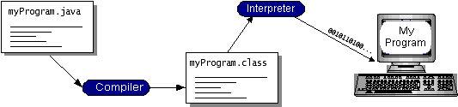

Java byte codes essentially function as machine code instructions for the Java Virtual Machine (Java VM). Every Java interpreter, whether in a development tool or a web browser handling applets, represents an implementation of the Java VM. The brilliance of Java byte codes lies in enabling the "write once, run anywhere" concept. You can compile your program into byte codes on any platform equipped with a Java compiler. These byte codes can then seamlessly run on any Java VM implementation. Consequently, a program written in Java can run uniformly across diverse platforms such as Windows 2000, Solaris workstations, or iMac computers, provided they have a Java VM installed. This universal adaptability underscores the inherent flexibility and portability of Java applications.

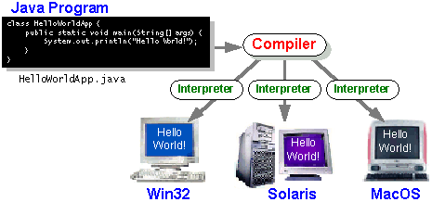

The Java Platform

The term "platform" refers to the environment, be it software or hardware, in which a program operates. Common platforms like Windows 2000, Linux, Solaris, and MacOS are often a blend of both operating systems and hardware. However, the Java platform stands distinctively apart as a software-only platform that functions atop other hardware-based systems.

Comprising the Java platform are two key components: the Java Virtual Machine (Java VM) and the Java Application Programming Interface (Java API). The Java VM serves as the foundational base for the Java platform and is adaptable across various hardware-based platforms. In contrast, the Java API constitutes an extensive repository of pre-developed software components, offering a plethora of functionalities, including graphical user interface (GUI) widgets. These capabilities are encapsulated into collections of related classes and interfaces termed as "packages."

Illustrated in a program running on the Java platform is the remarkable insulation provided by the Java API and the virtual machine from the underlying hardware, as depicted in the diagram.

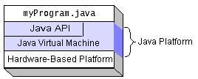

Distinguishing itself from native code—compiled code designed for specific hardware—the Java platform, operating in a platform-independent environment, might exhibit slightly reduced speed compared to native code. However, through sophisticated techniques such as smart compilers, well-optimized interpreters, and just-in-time bytecode compilers, the Java platform can achieve performance close to that of native code without compromising on its fundamental portability.

What Can Java Technology Do?
The Java programming language transcends beyond the realm of creating captivating web applets. It serves as a powerful software platform capable of developing a variety of programs. Within the Java ecosystem, programs are primarily categorized as applets and applications. Applets, familiar to web surfers, comply with specific standards enabling them to execute within Java-enabled browsers. Yet, Java's prowess extends far beyond this, offering a versatile platform for diverse program types.

Applications, standalone programs operating directly on the Java platform, include specialized servers like Web servers, mail servers, and servlets. Servlets, akin to server-side applets, substitute traditional CGI scripts and work within Java Web servers to customize server behavior.

Facilitating these diverse programs is the Java API, encompassing an array of software components grouped into packages, offering a broad spectrum of functionality:

1. Core Elements: Foundations like objects, strings, threads, data structures, and system properties.
2. Applets Conventions: Specifications required for applet execution.
3. Networking: Support for URLs, TCP, UDP sockets, and IP addresses.
4. Internationalization: Capabilities for global program adaptation, catering to specific locales and languages.
5. Security Measures: Encompassing electronic signatures, key management, access control, and certificates.
6. JavaBeansTM: Software components compatible with existing architectures.
7. Object Serialization: Facilitating lightweight persistence and communication through Remote Method Invocation (RMI).
8. JDBC™: Providing uniform database access across relational databases.

Moreover, the Java platform boasts an extensive range of APIs spanning 2D/3D graphics, accessibility, servers, collaboration, telephony, speech, animation, and more, as depicted in the Java 2 SDK. This comprehensive API ecosystem endows developers with an expansive toolkit for crafting diverse and sophisticated Java-based applications.

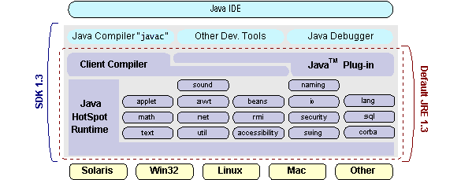

How Will Java Technology Change My Life?

If you learn to programme in Java, we can't guarantee you fame, wealth, or even a job. It still needs less work than other languages and will probably improve your programmes. We think the following are things that Java technology may assist you with:

Get going immediately: Despite being a strong object-oriented language, Java is simple to learn, especially for programmers who are already conversant with C or C++.
Reduce the amount of code you write: Programme metrics (class counts, method counts, etc.) comparisons indicate that a Java programme can be four times smaller than a C++ programme of the same kind.

Improve the code: Good coding practises are encouraged by the Java programming language, and garbage collection keeps memory leaks at bay. Its broad, readily extensible API, object orientation, and JavaBeans component design allow you to reuse other people's tested work and introduce fewer defects.

Produce programmes faster: If you write the identical programme in C++, your development time might be up to twice as quick. Why? Compared to C++, it is a simpler programming language and requires writing less lines of code.

Survive without platform requirements using only Java: By staying away from using libraries written in other languages, you can maintain the portability of your software. There is an online archive of previous procedure manuals, white papers, brochures, and similar resources available through the 100% Pure JavaTM Product Certification Programme.

Compose once, execute anywhere: Programmes written in 100% Pure Java execute reliably on every Java platform since they are compiled into machine-independent byte codes.
Make software distribution easier: Applet upgrades are simple to perform from a central server. Applets use the capability of "on-the-fly" loading of new classes without requiring a programme recompilation.

ODBC
A common programming interface used by database system providers and application developers is Microsoft Open Database Connectivity (ODBC). For Windows programmes to interface with database systems prior to ODBC being the de facto standard, programmers had to utilise proprietary languages for every database they want to connect to. As it should be, ODBC has now rendered the database system selection essentially meaningless from a coding standpoint. When business demands unexpectedly change, application developers have far more essential things to worry about than the syntax required to move their programme from one database to another.

You can choose the specific database that is linked to a data source that an ODBC application programme is intended to utilise by using the ODBC Administrator in the Control Panel. Consider an ODBC data source to be a named door. You will be directed to a certain database by each door. A SQL Server database, for instance, may be the source of the Sales Figures data source, whereas an Access database might be the source of the Accounts Payable data source. Anywhere on the LAN can be home to the actual database that a data source references.

Windows 95 does not come pre-installed with the ODBC system files. Instead, they are installed during the startup of a different database programme, such Visual Basic 4.0 or SQL Server Client. A file named ODBCINST.DLL is used when the Control Panel's ODBC icon is installed. You may also use ODBCADM.EXE, a stand-alone programme, to manage your ODBC data sources. This programme comes in 16- and 32-bit versions, and each one keeps a different list of ODBC data sources.

Programmatically speaking, the beauty of ODBC is that an application can be created to connect with any data source, regardless of database vendor, using the same set of function calls. Whether the programme communicates with SQL Server or Oracle doesn't affect its source code. These are the only two we bring up as examples. ODBC drivers are available for a number of well-known database systems. It is possible to convert plain text files and Excel spreadsheets into data sources. The operating system determines which low-level ODBC drivers are required to communicate with the data source (such as the Oracle or SQL Server interface) using the Registry information supplied by the ODBC Administrator. The ODBC application programme can see how the ODBC drivers are loaded. The ODBC API even takes care of a lot of the network problems for the application programmer in a client/server setup.
Given how many benefits this plan offers, you're undoubtedly wondering if there's a catch. Talking directly to the native database interface is more efficient than using ODBC, which is its lone drawback. Many critics of ODBC have said that it moves too slowly. Microsoft has consistently maintained that the calibre of the driver software being used determines how well a system performs. We humbly believe that this is accurate. The quality of ODBC drivers is now much more widely available. Furthermore, the critique about performance bears some resemblance to the assertion made by some that compilers will never surpass the speed of pure assembly code. Perhaps not, but using the compiler (or ODBC) allows you to develop programmes more efficiently, which saves time. In the meantime, every year, computers become quicker.

JDBC

Java Database Connectivity, or JDBC, was created by Sun Microsystems in an attempt to provide an independent database standard API for Java. The generic SQL database access technique provided by JDBC gives a uniform interface to a range of RDBMSs. Through the use of "plug-in" database connectivity modules, or drivers, this uniform interface is made possible. A database vendor needs to supply the driver for every platform that Java and the database are used on in order to offer JDBC functionality.
Sun built the foundation of JDBC on ODBC in order to increase its acceptability. As you learned previously in this chapter, ODBC is widely supported across many different platforms. Vendors may provide JDBC drivers considerably more quickly to the market by basing JDBC on ODBC rather than creating a whole new connection solution.
The JDBC was unveiled in March 1996. It was made available for public review for ninety days, ending on June 8, 1996. Soon later, the final JDBC v1.0 standard was published as a result of user feedback.
This section will provide you enough background on JDBC to understand what it is and how to utilise it efficiently. This is by no means an exhaustive introduction to JDBC. That may take up a whole book.

JDBC Goals

Software packages are rarely created without objectives in mind. One that influenced the creation of the API was JDBC due to its several objectives. These objectives, together with early reviewer input, have made the JDBC class library a stable foundation upon which to develop Java database applications.
The objectives that JDBC was given are significant. They will help you understand why specific functions and classes act in the ways that they do. The following are the eight JDBC design objectives:

- SQL Level API
The creators believed that defining a SQL interface for Java was their primary objective. It's not the lowest feasible database interface level, but it's low enough to allow for the creation of higher-level tools and APIs. On the other hand, it is sophisticated enough for application programmers to utilise it with assurance. By doing this, next tool providers will be able to "generate" JDBC code and shield the user from many of the complexity of JDBC.
- SQL Conformance
The SQL syntax differs depending on whatever database provider you choose. JDBC allows any query statement to be transmitted over it to the underlying database driver in an attempt to accommodate a large number of vendors. This enables non-standard functionality to be handled by the connection module in a way that makes sense for its users.

- JDBC must be implemental on top of common database interfaces
Other widely used SQL level APIs must "sit" above the JDBC SQL API. With the use of a software interface, this aim enables JDBC to make use of the current ODBC level drivers. JDBC calls would be converted to ODBC calls using this interface, and vice versa.

4. Provide an interface for Java that is compatible with the entire Java system.

The designers believe that they shouldn't deviate from the present architecture of the core Java system due to Java's up to this point acceptability among the user community.

5. Make things easy

Most goal listings for software design certainly include this one. JDBC is no different. Sun believed that JDBC should have a very basic architecture that only allowed one way to accomplish a job per mechanism. Permitting redundant functionality just makes API consumers more perplexed.

6. Whenever feasible, type in a strong, static manner.
Robust typing enables increased compile-time error checks and less run-time error appearance.

7. Make the usual circumstances straightforward
These queries should be easy to execute with JDBC since most of the time, the typical SQL calls used by the programmer are straightforward SELECT, INSERT, DELETE, and UPDATE commands. More intricate SQL statements ought to be conceivable nonetheless.

In the end, we chose to move on with the Java Networking implementation.
Additionally, we use an MS Access database to update the cache table dynamically.
Java is both a platform and a programming language.
High-level programming languages like Java include all of the following

Simple Architecture-neutral
Object-oriented Portable
Distributed High-performance
Interpreted multithreaded
Robust Dynamic
Secure

Another unique feature of Java is that every Java programme is both interpreted and compiled. By using a compiler, you may convert a Java programme into Java byte codes, which are an intermediate language that the computer can understand and use to execute platform-independent code.

While interpretation happens each time the programme is run, compilation only happens once. This is seen in the illustration.
Compilation happens just once; interpretation occurs each time the program is executed. The figure illustrates how this works.

Java Program
Compilers
Interpreter
My Program

Java byte codes serve as the machine code instructions for the Java Virtual Machine (Java VM). Any Java interpreter, be it a Java development tool or a web browser capable of running Java applets, represents an instantiation of the Java VM. It's noteworthy that the Java VM can even find implementation in hardware.

The essence of Java byte codes lies in enabling the "write once, run anywhere" paradigm. By compiling your Java program into byte codes using a Java compiler on a specific platform, these byte codes become executable on any implementation of the Java VM. This implies that a single Java program has the capability to run seamlessly on diverse platforms such as Windows NT, Solaris, and Macintosh.

Networking

TCP/IP stack
The TCP/IP stack is shorter than the OSI one:

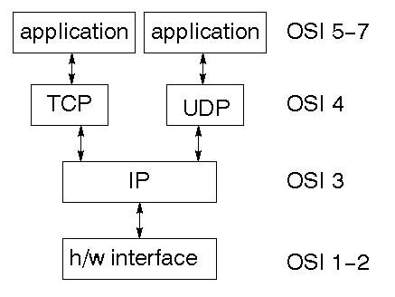

TCP is a connection-oriented protocol; UDP (User Datagram Protocol) is a connectionless protocol.

IP datagram’s
An unstable and connectionless delivery mechanism is offered by the IP layer. Every datagram is taken into account separately from the others. The upper layers are required to supply any associations between datagrams. An own header-containing checksum is provided by the IP layer. The source and destination addresses are included in the header. Internet routing is managed by the IP layer. Large datagrams must also be divided into smaller ones for transmission, then put back together at the other end by it.

UDP
UDP is also connectionless and unreliable. What it adds to IP is a checksum for the contents of the datagram and port numbers. These are used to give a client/server mode

TCP

TCP supplies logic to give a reliable connection-oriented protocol above IP. It provides a virtual circuit that two processes can use to communicate.

Internet addresses
A service has to be accessible for you to utilise. Machines on the Internet may be found using an address system. The IP address is provided by the address, which is a 32-bit integer. This encrypts additional addresses and a network ID. Depending on the size of the network address, there are several classifications for the network ID.

Network address
Class A uses 8 bits for the network address with 24 bits left over for other addressing. Class B uses 16 bit network addressing. Class C uses 24 bit network addressing and class D uses all 32.

Subnet address
Internally, the UNIX network is divided into sub networks. Building 11 is currently on one sub network and uses 10-bit addressing, allowing 1024 different hosts.

Host address
8 bits are finally used for host addresses within our subnet. This places a limit of 256 machines that can be on the subnet.

Total address

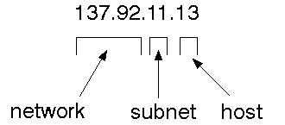
The 32 bit address is usually written as 4 integers separated by dots.

Port addresses
A service exists on a host, and is identified by its port. This is a 16 bit number. To send a message to a server, you send it to the port for that service of the host that it is running on. This is not location transparency! Certain of these ports are "well known".

Sockets
A socket is a data structure maintained by the system to handle network connections. A socket is created using the call socket. It returns an integer that is like a file descriptor. In fact, under Windows, this handle can be used with Read File and Write File functions.
#include <sys/types.h>
#include <sys/socket.h>
int socket(int family, int type, int protocol);
Here "family" will be AF_INET for IP communications, protocol will be zero, and type will depend on whether TCP or UDP is used. Two processes wishing to communicate over a network create a socket each. These are similar to two ends of a pipe - but the actual pipe does not yet exist.
JFree Chart
JFreeChart is a free 100% Java chart library that makes it easy for developers to display professional quality charts in their applications. JFreeChart's extensive feature set includes:
A consistent and well-documented API, supporting a wide range of chart types;
A flexible design that is easy to extend, and targets both server-side and client-side applications;
Support for many output types, including Swing components, image files (including PNG and JPEG), and vector graphics file formats (including PDF, EPS and SVG);
JFreeChart is "open source" or, more specifically, free software. It is distributed under the terms of the GNU Lesser General Public Licence (LGPL), which permits use in proprietary applications.

1. Map Visualizations
Charts showing values that relate to geographical areas. Some examples include: (a) population density in each state of the United States, (b) income per capita for each country in Europe, (c) life expectancy in each country of the world. The tasks in this project include:
Sourcing freely redistributable vector outlines for the countries of the world, states/provinces in particular countries (USA in particular, but also other areas);
Creating an appropriate dataset interface (plus default implementation), a rendered, and integrating this with the existing XYPlot class in JFreeChart;
Testing, documenting, testing some more, documenting some more.

2. Time Series Chart Interactivity

Implement a new (to JFreeChart) feature for interactive time series charts --- to display a separate control that shows a small version of ALL the time series data, with a sliding "view" rectangle that allows you to select the subset of the time series data to display in the main chart.

3. Dashboards

There is currently a lot of interest in dashboard displays. Create a flexible dashboard mechanism that supports a subset of JFreeChart chart types (dials, pies, thermometers, bars, and lines/time series) that can be delivered easily via both Java Web Start and an applet.

4. Property Editors

The property editor mechanism in JFreeChart only handles a small subset of the properties that can be set for charts. Extend (or reimplement) this mechanism to provide greater end-user control over the appearance of the charts.

J2ME (Java 2 Micro edition):-
Sun Microsystems defines J2ME as "a highly optimized Java run-time environment targeting a wide range of consumer products, including pagers, cellular phones, screen-phones, digital set-top boxes and car navigation systems." Announced in June 1999 at the JavaOne Developer Conference, J2ME brings the cross-platform functionality of the Java language to smaller devices, allowing mobile wireless devices to share applications. With J2ME, Sun has adapted the Java platform for consumer products that incorporate or are based on small computing devices.

1. General J2ME architecture

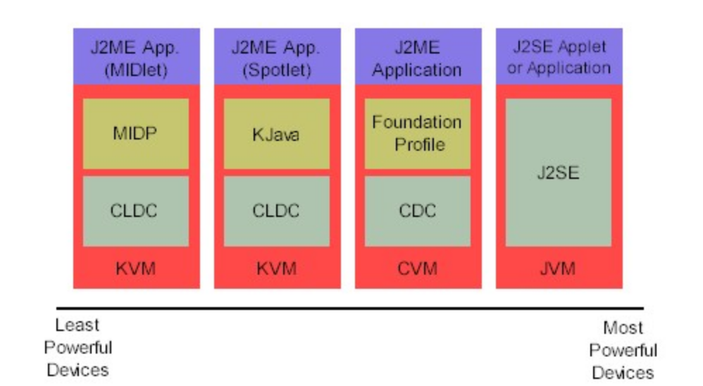

J2ME employs configurations and profiles to tailor the Java Runtime Environment (JRE) to specific requirements. Functioning as a comprehensive JRE, J2ME consists of a configuration, which dictates the JVM utilized, and a profile, which augments domain-specific classes to define the application. The configuration outlines the fundamental runtime environment, comprising core classes and a designated JVM tailored for specific device types. Detailed discussions on configurations will be presented later.

On the other hand, the profile shapes the application, introducing domain-specific classes to the J2ME configuration, thereby specifying certain device uses. In-depth exploration of profiles will be provided in the upcoming section. Illustrated below is a graphical representation illustrating the interplay between various virtual machines, configurations, and profiles. It also draws a parallel with the J2SE API and its Java virtual machine. While the J2SE virtual machine is commonly referred to as a JVM, the J2ME virtual machines, KVM and CVM, can be considered subsets of the JVM. Both KVM and CVM function as a type of Java virtual machine, albeit scaled-down versions of the J2SE JVM, specifically designed for J2ME.

2. Developing J2ME applications
Introduction In this section, we will go over some considerations you need to keep in mind when developing applications for smaller devices. We'll take a look at the way the compiler is invoked when using J2SE to compile J2ME applications. Finally, we'll explore packaging and deployment and the role preverification plays in this process.
- Design considerations for small devices
When developing applications for small devices, it's crucial to incorporate specific strategies during the design phase. Ideally, strategic planning should precede the coding process, as rectifying oversights later can be a cumbersome task. Consider the following design strategies:

1. Simplicity is Key: Prioritize simplicity by eliminating unnecessary features. Consider segregating these features into a separate, secondary application.

2. Embrace Compactness: Opt for smaller designs. Smaller applications not only consume less memory on the device but also boast quicker installation times. Packaging Java applications as compressed Java Archive (JAR) files can be advantageous.

- Optimize Run-time Memory Usage: Minimize memory consumption during runtime by utilizing scalar types instead of object types. Avoid relying heavily on the garbage collector; efficiently manage memory by setting object references to null when no longer needed. Adopt lazy instantiation, allocating objects only when necessary. Additionally, reduce overall and peak memory use by promptly releasing resources, reusing objects, and minimizing exceptions.
4. Configurations overview
The configuration defines the basic run-time environment as a set of core classes and a specific JVM that run on specific types of devices. Currently, two configurations exist for J2ME, though others may be defined in the future:
Connected Limited Device Configuration (CLDC) is used specifically with the KVM for 16-bit or 32-bit devices with limited amounts of memory. This is the configuration (and the virtual machine) used for developing small J2ME applications. Its size limitations make CLDC more interesting and challenging (from a development point of view) than CDC. CLDC is also the configuration that we will use for developing our drawing tool application. An example of a small wireless device running small applications is a Palm hand-held computer.

Connected Device Configuration (CDC) is used with the C virtual machine (CVM) and is used for 32-bit architectures requiring more than 2 MB of memory. An example of such a device is a Net TV box.

5. J2ME profiles
What is a J2ME profile?
J2ME defines the supported device type. The Mobile Information Device Profile (MIDP), for instance, introduces classes tailored for cellular phones, extending the J2ME configuration to delineate specific uses for similar devices. Two established profiles, KJava and MIDP, are built on the Connected Limited Device Configuration (CLDC), designed for smaller devices. Profiles, being built on top of configurations, are device-specific due to varying memory constraints. The Foundation Profile, a skeleton profile available for CDC, provides a basis for creating custom profiles.

Profile 1: KJava
KJava, a proprietary profile by Sun, incorporates the KJava API and builds upon the CLDC configuration. The KJava virtual machine (KVM) accepts the same byte codes and class file format as the classic J2SE virtual machine. Tailored for the Palm OS, KJava features a Sun-specific API resembling the J2SE Abstract Windowing Toolkit (AWT). Notably, its main package is com.sun.kjava. A more in-depth exploration of the KJava API will be undertaken later in this tutorial when developing sample applications.

Profile 2: MIDP
Geared towards mobile devices like cellular phones and pagers, MIDP is another profile built on CLDC. It offers a standardized runtime environment enabling dynamic deployment of applications and services on end-user devices. Unlike KJava, MIDP is an industry-standard profile not tied to a specific vendor. It serves as a comprehensive foundation for mobile application development, encompassing core CLDC packages (java.lang, java.io, java.util) and three MIDP-specific packages (javax.microedition.io, javax.microedition.lcdui, javax.microedition.midlet, javax.microedition.rms).

MYSQL:
What is a Database?
MySQL, a swift and user-friendly Relational Database Management System (RDBMS), is widely adopted by both small and large businesses. Developed, marketed, and supported by the Swedish company MySQL AB, it has gained popularity for several compelling reasons:

1. Open-Source Advantage: MySQL is released under an open-source license, eliminating the need for any payment to use the software.

2. Powerful Functionality: Despite its modest size, MySQL is powerful, handling a substantial subset of functionalities found in more expensive database packages.

3. SQL Compatibility: MySQL employs a standard form of the well-known SQL data language, ensuring compatibility and ease of use.

4. Versatility in Operating Systems and Languages: Compatible with various operating systems, MySQL works seamlessly with languages such as PHP, PERL, C, C++, JAVA, etc.

5. Efficient Performance: MySQL operates swiftly, even with large datasets, making it a preferred choice for businesses.

6. Integration with PHP: Recognized for its compatibility with PHP, a widely appreciated language for web development.

7. Support for Large Databases: MySQL supports substantial databases, accommodating up to 50 million rows or more in a table. It allows customization of file size limits for tables.

8. Customizability: The open-source GPL license permits programmers to modify the MySQL software to suit specific environments.

MySQL Introduction:
MySQL, often referred to as "the world’s most popular open-source database," has introduced millions to powerful information systems. It is a recent entrant into relational database management systems (RDBMS) but has quickly become a workhorse in the information world. Its ease of installation and scalability have made it a driving force in creating custom, niche applications.

Why MySQL is Popular:
MySQL's popularity can be attributed to factors like its size and speed, ease of installation, responsiveness to the community, and an easy interface with other software. MySQL's dual-license approach, open-source nature, and extensive language support contribute to its widespread adoption.

Whether serving small organizations on modest hardware or meeting the needs of larger sites, MySQL's efficiency, flexibility, and community support make it a preferred choice for database management.

3.2 Project Analysis

EXISTING SYSTEM:
- The majority of existing visa management systems rely on manual labour. Visas are manually generated at a visa office. Applicants must submit hard copies of their documents to the visa office, which will store them at their local warehouse.
- An HR Manager assigns an HR Executive to process the applicant data. This executive is responsible for receiving application files from the warehouse and adding his/her work (findings and eligibility checks) to the applicant file.
- The application is then accepted or rejected based on the applicant's eligibility.

.DISADVANTAGES OF EXISTING SYSTEM:
- The current system necessitates numerous manual entries.
- Human error can occur during the process if manual entries are used.
- Cash transactions take time to complete.
- Storage space expands over time.
- The transfer of credentials between departments is always subject to a time lag.
- Labor costs are high.

PROPOSED SYSTEM:
- In this project, we worked on the shortcomings of existing manual models. We used software-based systems to improve the process's efficiency, reliability, security, and convenience.
- The Visa Processing System (VPS) is a web-based tool that helps bridge the communication gap between the Visa Officer and the Applicant. Technology, particularly in the rapidly growing IT market, is changing at a breakneck pace; based on technology, it reduces the manual process of visa processing. This process will make visa processing very simple and quick, and the applicant will be able to apply for a visa, fill out an i20 form, and check the status of their visa in one sitting.
- The main goal of this solution is to make visa processing as simple as possible. This system is designed with both parties, such as visa processing officers and applicants, in mind. The system enables applicants to apply for visas, i20 forms, and so on.

ADVANTAGES OF PROPOSED SYSTEM:
- The proposed system automated manual processes such as visa application, status check, visa enquiry, executive assignment, file transfer, and so on.
- Overall, automation results in a faster pace.
- It lessens the workload associated with file transfer and storage.
- It eliminates any mistakes made during the application process.
- Any change in application data can be tracked, and any updates are reflected across the network almost instantly.
- Online application portals make applying for a visa easier for any user.

3.3 System Design

3.3.1 System Requirements

HARDWARE REQUIREMENTS:

- System : Pentium i3 Processor
- Hard Disk : 500 GB.
- Monitor : 15’’ LED
- Input Devices : Keyboard, Mouse
- Ram : 2 GB

SOFTWARE REQUIREMENTS:

- Operating system : Windows 10.
- Coding Language : JAVA.
- Tool : Netbeans 8.2
- Database : MYSQL

3.3.2 System Architecture OR Block Diagram

SYSTEM ARCHITECTURE:

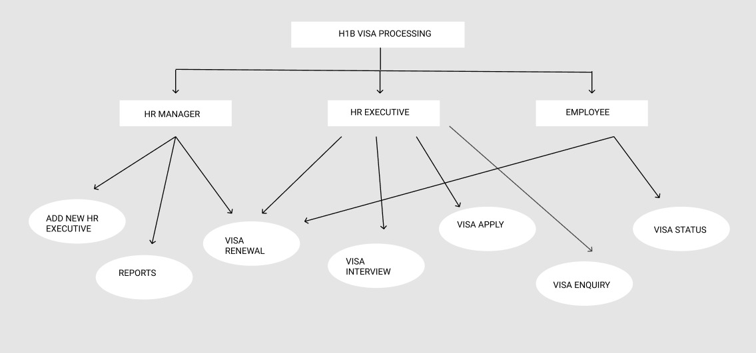

DATA FLOW DIAGRAM:

- The DFD is also called as bubble chart. It is a simple graphical formalism that can be used to represent a system in terms of input data to the system, various processing carried out on this data, and the output data is generated by this system.
- The data flow diagram (DFD) is one of the most important modeling tools. It is used to model the system components. These components are the system process, the data used by the process, an external entity that interacts with the system and the information flows in the system.
- DFD shows how the information moves through the system and how it is modified by a series of transformations. It is a graphical technique that depicts information flow and the transformations that are applied as data moves from input to output.
- DFD is also known as bubble chart. A DFD may be used to represent a system at any level of abstraction. DFD may be partitioned into levels that represent increasing information flow and functional detail.

Employee/User
Login
Validate
Visa Application Entry
Enquiry Entry
Interview Schedules Entry
Results Entry
Onsite Departure
Onsite Arrival
Logout
HR Executive Management
Employees Management
Enquiry Report
Interview Report
Results Reports
Visa Process Report
Visa Renewal Report
Visa Renewal
Visa Process Status
Send Report
HR Executive
ADMIN

UML DIAGRAMS

UML stands for Unified Modeling Language. UML is a standardized general-purpose modeling language in the field of object-oriented software engineering. The standard is managed, and was created by, the Object Management Group.
The goal is for UML to become a common language for creating models of object oriented computer software. In its current form UML is comprised of two major components: a Meta-model and a notation. In the future, some form of method or process may also be added to; or associated with, UML.
The Unified Modeling Language is a standard language for specifying, Visualization, Constructing and documenting the artifacts of software system, as well as for business modeling and other non-software systems.
The UML represents a collection of best engineering practices that have proven successful in the modeling of large and complex systems.
The UML is a very important part of developing objects oriented software and the software development process. The UML uses mostly graphical notations to express the design of software projects.

GOALS:
The Primary goals in the design of the UML are as follows:
- Provide users a ready-to-use, expressive visual modeling Language so that they can develop and exchange meaningful models.
- Provide extendibility and specialization mechanisms to extend the core concepts.
- Be independent of particular programming languages and development process.
- Provide a formal basis for understanding the modeling language.
- Encourage the growth of OO tools market.
- Support higher level development concepts such as collaborations, frameworks, patterns and components.
- Integrate best practices.

USE CASE DIAGRAM:
A use case diagram in the Unified Modeling Language (UML) is a type of behavioral diagram defined by and created from a Use-case analysis. Its purpose is to present a graphical overview of the functionality provided by a system in terms of actors, their goals (represented as use cases), and any dependencies between those use cases. The main purpose of a use case diagram is to show what system functions are performed for which actor. Roles of the actors in the system can be depicted.

Hr Executive
Visa Processingng
Visa App. Entry
Visa Processor
Visa Enquiry
Visa Interview
Onsite Details
Hr Manager
Administrator
Visa
Details
Visa
Details
Nominee
Details
Hr Executive
Hr Executive

CLASS DIAGRAM:
In software engineering, a class diagram in the Unified Modeling Language (UML) is a type of static structure diagram that describes the structure of a system by showing the system's classes, their attributes, operations (or methods), and the relationships among the classes. It explains which class contains information.

Application

Update entry ()
Interview
Schedule()
Change ()
Onsite Arrival

Store Info ()
Employee/User
Update ()
View ()
Executive
Update ()
Display ()
Results

Generate ()
Onsite Departure

Store Info ()
Renewal

Update ()

SEQUENCE DIAGRAM:
A sequence diagram in Unified Modeling Language (UML) is a kind of interaction diagram that shows how processes operate with one another and in what order. It is a construct of a Message Sequence Chart. Sequence diagrams are sometimes called event diagrams, event scenarios, and timing diagrams.

User/Employee

Database
Login
Login

Login

Register

HR Manager
HR Executive

Authorize User

Update Details
View Reports
Apply Visa

Get Status
Visa Renewal

Interviews
Add HR Executive
View Reports

ACTIVITY DIAGRAM:
Activity diagrams are graphical representations of workflows of stepwise activities and actions with support for choice, iteration and concurrency. In the Unified Modeling Language, activity diagrams can be used to describe the business and operational step-by-step workflows of components in a system. An activity diagram shows the overall flow of control.

Employee/User
Login
Validate
Visa Application Entry
Enquiry Entry
Interview Schedules Entry
Results Entry
Onsite Departure
Onsite Arrival
Logout
HR Executive Management
Employees Management
Enquiry Report
Interview Report
Results Reports
Visa Process Report
Visa Renewal Report
Visa Renewal
Visa Process Status
Send Report
HR Executive
ADMIN

Chapter 4

IMPLEMENTATION
MODULES
- Admin module
- Visa processing module
- Communication module
- Report Handler Module

MODULES DESCRIPTION:
Admin Module
This module is controlled by HR executive. The HR executive job is to controls the visa processing process which is assign by HR manager. HR manager job is to create the new HR executives and give the employee/officer their username and password details. HR executive details will be stored in employee database. The HR executive can view customer application about applying for new visa or the renewal of their existing visa, and they generate their application status report and their result report. The HR manager has the authority over HR executive. They can view application entries, enquiry details, result details, onsite arrival and departure details.
Visa processing module:
This module is considered as the main module. It processes the details of submitted application, details of passport, earlier visits, and their tour details. These processes are done by HR executive. When the applicant applies for visa their application will go under through the process of enquiry and interviews held by the consulates. These details are stored in this module, and the end result is also entered in this module.
Communication module:
This module contain the information about visa issuing date, flight date, Numbers of day spend abroad and returning date of the candidate. These details will be entered by HR executive. Candidate details are like why they need the visa and renewal request for visa. Candidate’s requests for renewal are viewed by HR Manager. Candidates can view their visa renewal information and visa process status in this module only.
Report Handler Module:
This module handles the reports of applicant application status which are handled by HR executives.

4.2 Testing OR Verification Plan

The purpose of testing is to discover errors. Testing is the process of trying to discover every conceivable fault or weakness in a work product. It provides a way to check the functionality of components, sub- assemblies, assemblies and/or a finished product It is the process of exercising software with the intent of ensuring that the
Software system meets its requirements and user expectations and does not fail in an unacceptable manner. There are various types of test. Each test type addresses a specific testing requirement.

TYPES OF TESTS

Unit testing
Unit testing involves the design of test cases that validate that the internal program logic is functioning properly, and that program inputs produce valid outputs. All decision branches and internal code flow should be validated. It is the testing of individual software units of the application .it is done after the completion of an individual unit before integration. This is a structural testing, that relies on knowledge of its construction and is invasive. Unit tests perform basic tests at component level and test a specific business process, application, and/or system configuration. Unit tests ensure that each unique path of a business process performs accurately to the documented specifications and contains clearly defined inputs and expected results.

Integration testing

Integration tests are designed to test integrated software components to determine if they actually run as one program. Testing is event driven and is more concerned with the basic outcome of screens or fields. Integration tests demonstrate that although the components were individually satisfaction, as shown by successfully unit testing, the combination of components is correct and consistent. Integration testing is specifically aimed at exposing the problems that arise from the combination of components.

Functional test

Functional tests provide systematic demonstrations that functions tested are available as specified by the business and technical requirements, system documentation, and user manuals.
Functional testing is centered on the following items:
Valid Input : identified classes of valid input must be accepted.
Invalid Input : identified classes of invalid input must be rejected.
Functions : identified functions must be exercised.
Output : identified classes of application outputs must be exercised.
Systems/Procedures: interfacing systems or procedures must be invoked.

Organization and preparation of functional tests is focused on requirements, key functions, or special test cases. In addition, systematic coverage pertaining to identify Business process flows; data fields, predefined processes, and successive processes must be considered for testing. Before functional testing is complete, additional tests are identified and the effective value of current tests is determined.

System Test
System testing ensures that the entire integrated software system meets requirements. It tests a configuration to ensure known and predictable results. An example of system testing is the configuration oriented system integration test. System testing is based on process descriptions and flows, emphasizing pre-driven process links and integration points.

White Box Testing
White Box Testing is a testing in which in which the software tester has knowledge of the inner workings, structure and language of the software, or at least its purpose. It is purpose. It is used to test areas that cannot be reached from a black box level.

Black Box Testing
Black Box Testing is testing the software without any knowledge of the inner workings, structure or language of the module being tested. Black box tests, as most other kinds of tests, must be written from a definitive source document, such as specification or requirements document, such as specification or requirements document. It is a testing in which the software under test is treated, as a black box .you cannot “see” into it. The test provides inputs and responds to outputs without considering how the software works.

6.1 Unit Testing:

Unit testing is usually conducted as part of a combined code and unit test phase of the software lifecycle, although it is not uncommon for coding and unit testing to be conducted as two distinct phases.

Test strategy and approach
Field testing will be performed manually and functional tests will be written in detail.

Test objectives
- All field entries must work properly.
- Pages must be activated from the identified link.
- The entry screen, messages and responses must not be delayed.

Features to be tested
- Verify that the entries are of the correct format
- No duplicate entries should be allowed
- All links should take the user to the correct page.

6.2 Integration Testing

Software integration testing is the incremental integration testing of two or more integrated software components on a single platform to produce failures caused by interface defects.
The task of the integration test is to check that components or software applications, e.g. components in a software system or – one step up – software applications at the company level – interact without error.

Test Results: All the test cases mentioned above passed successfully. No defects encountered.

6.3 Acceptance Testing

User Acceptance Testing is a critical phase of any project and requires significant participation by the end user. It also ensures that the system meets the functional requirements.

Test Results: All the test cases mentioned above passed successfully. No defects encountered.

4.3 Screenshots

SCREEN SHOTS

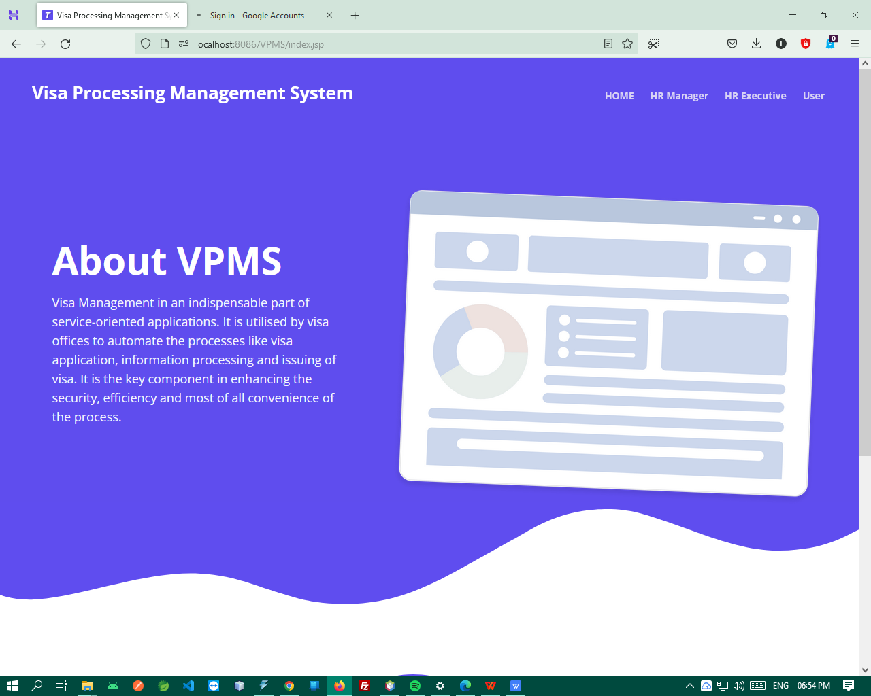

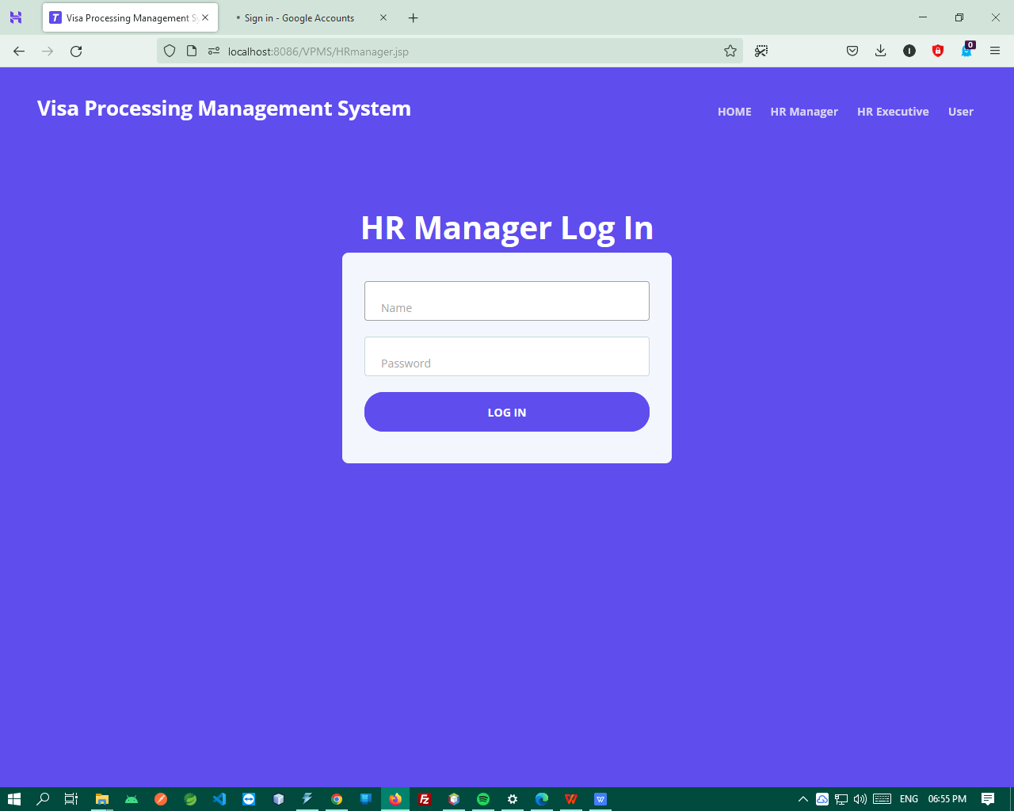

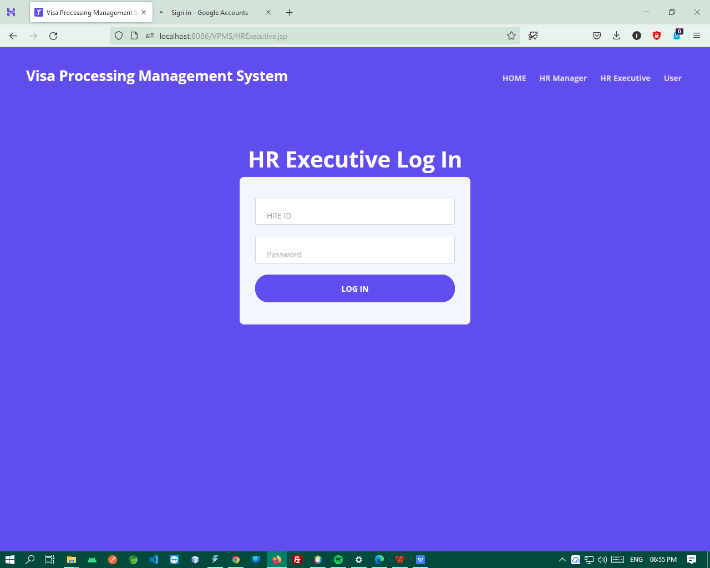

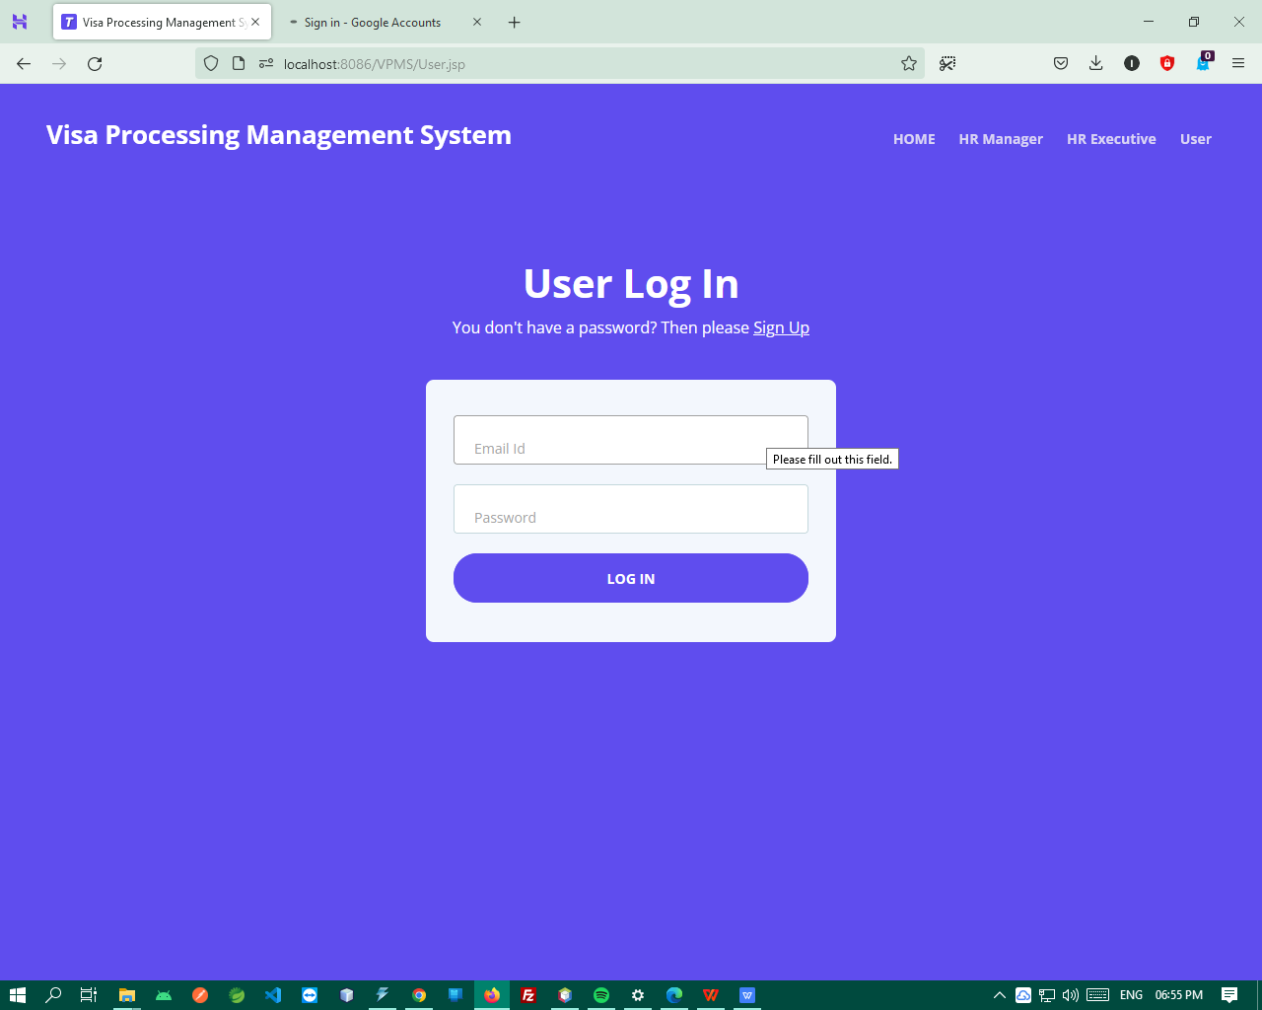

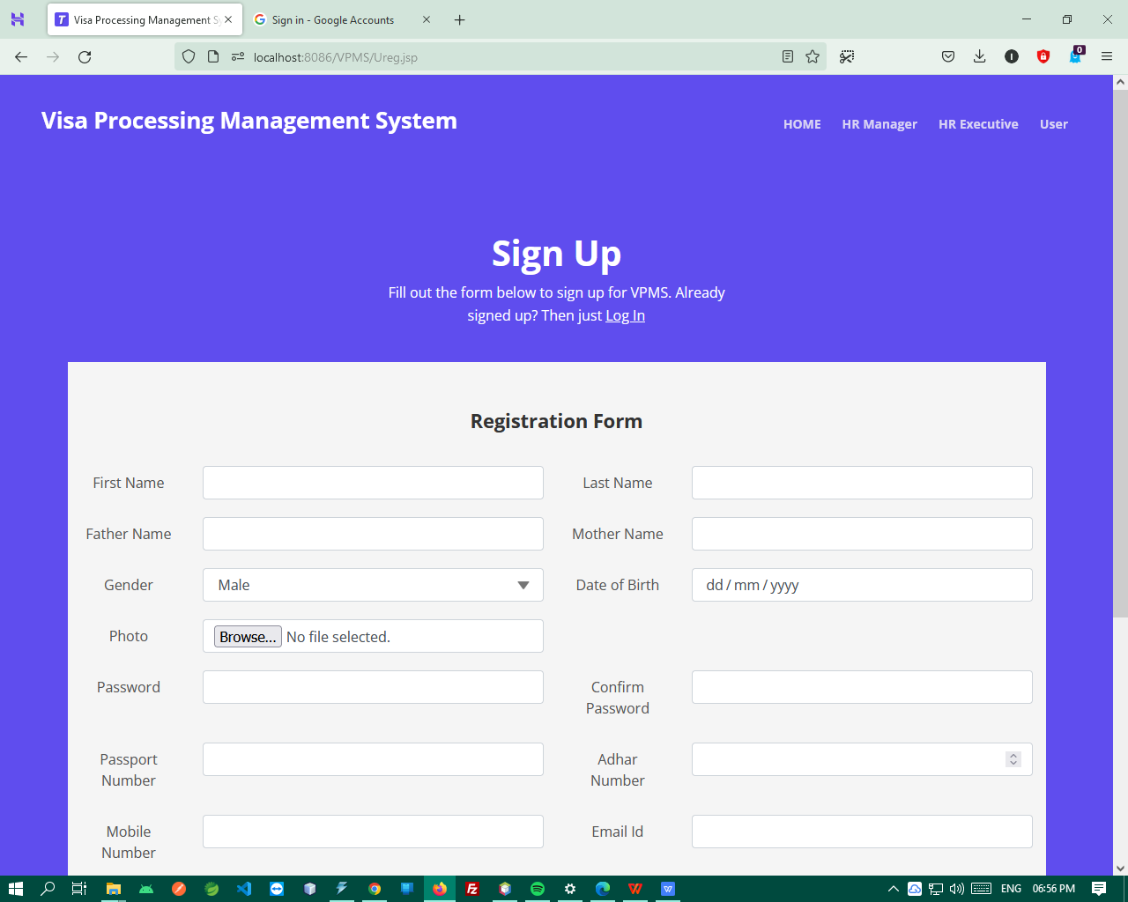



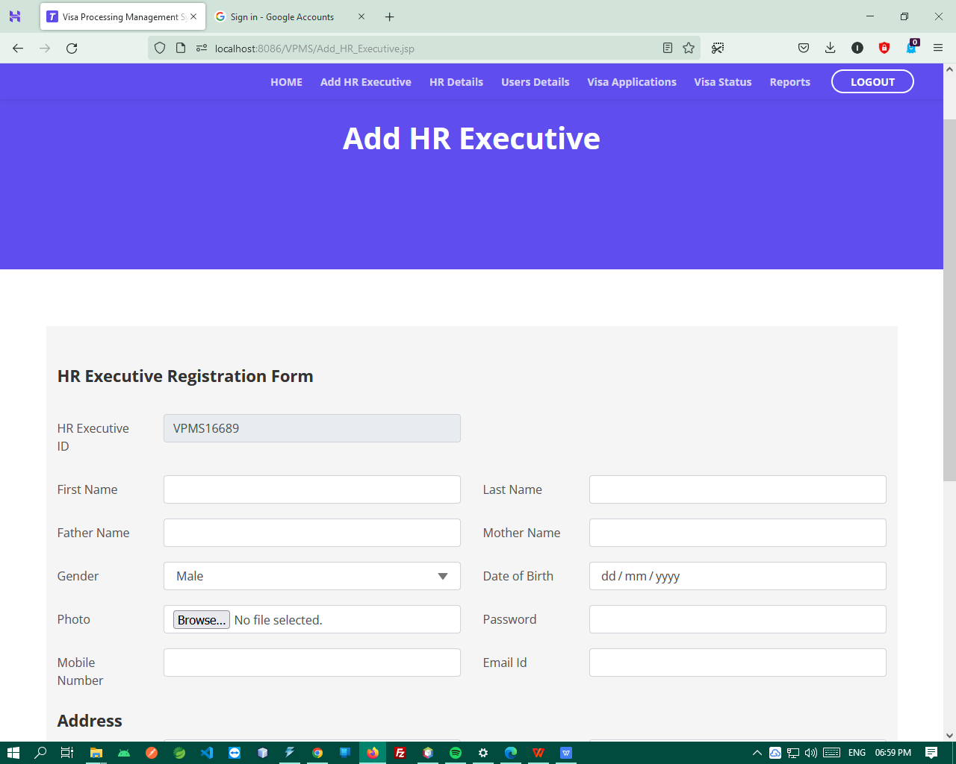

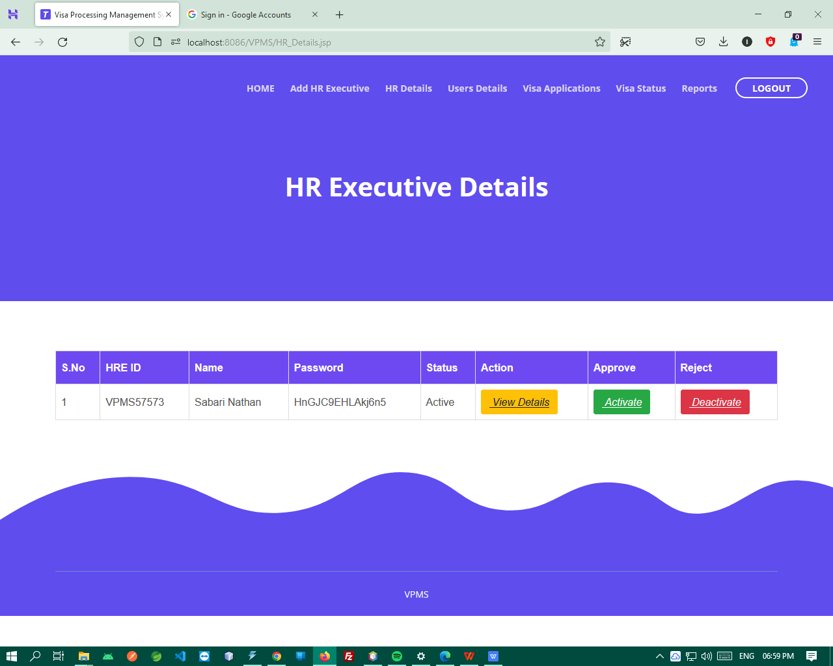

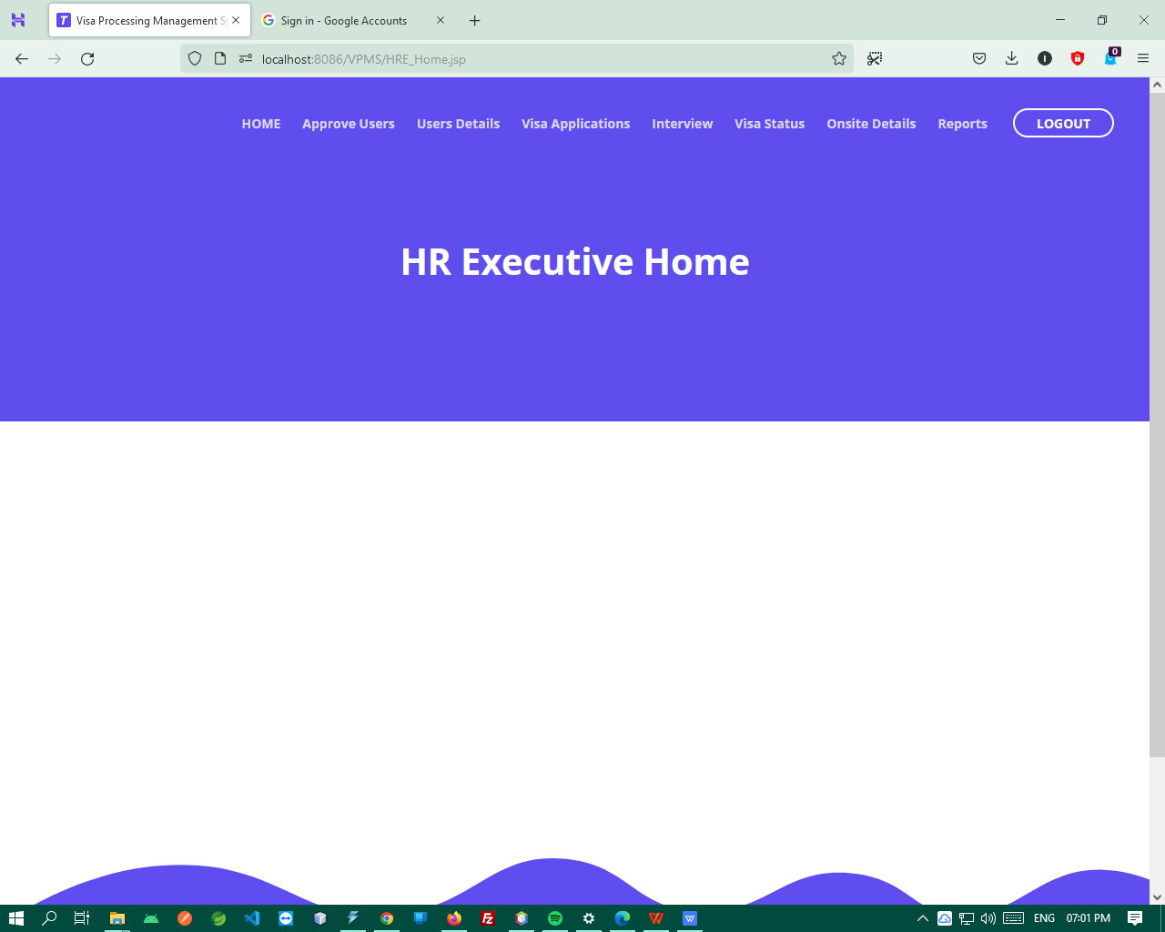

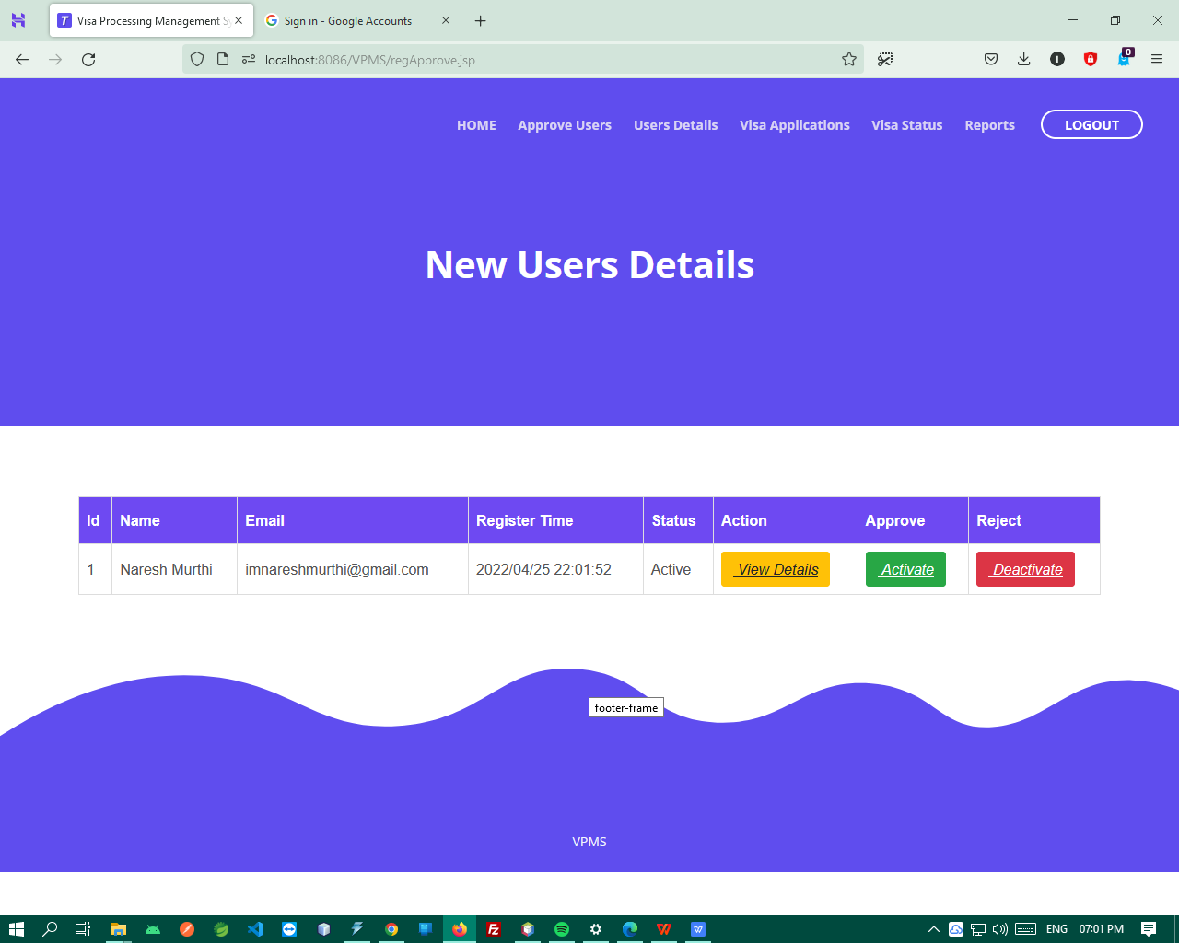

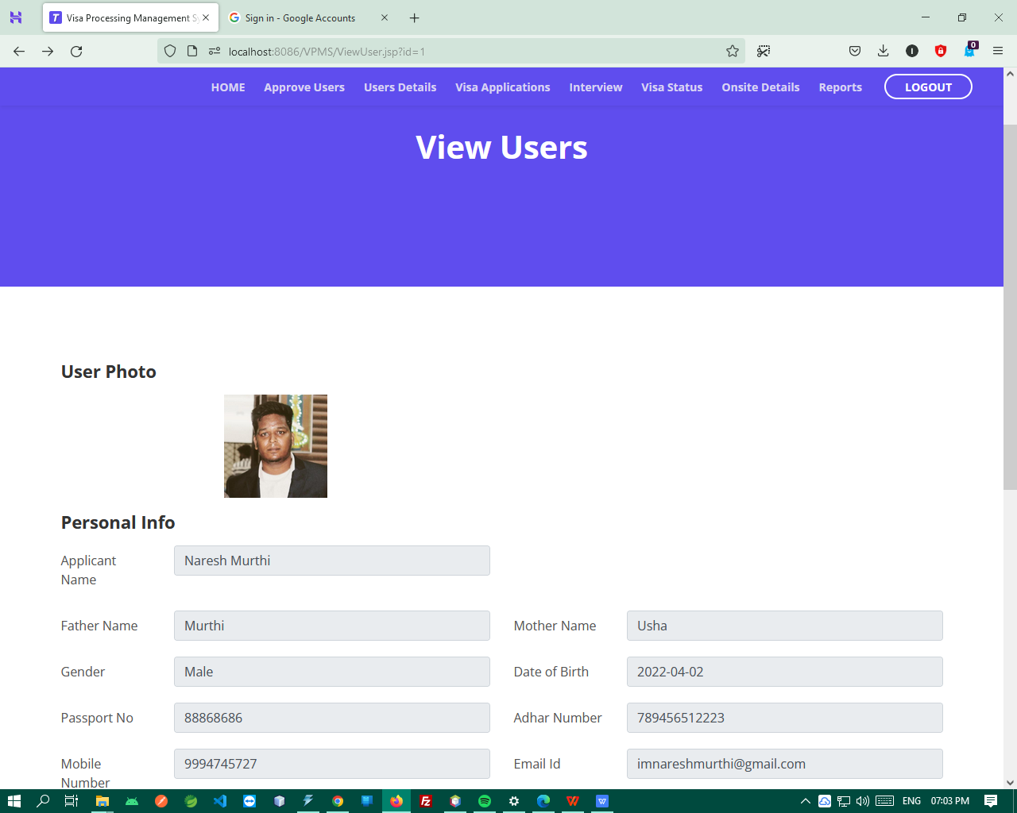

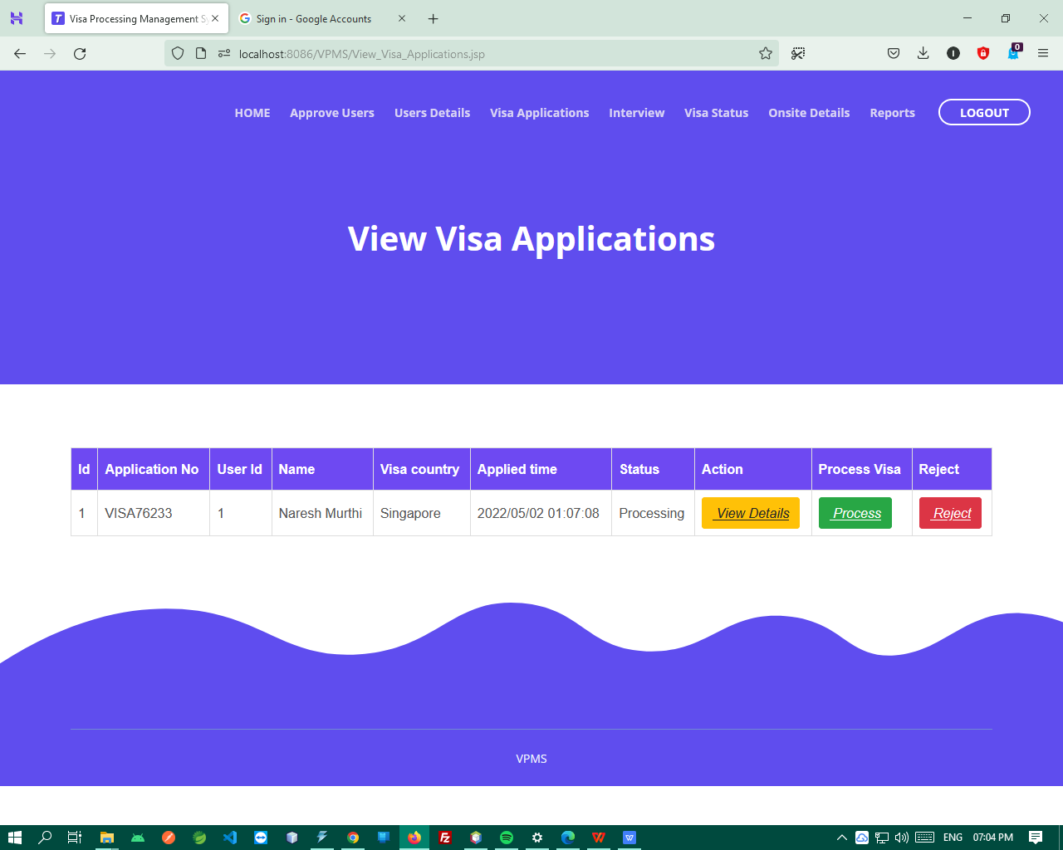

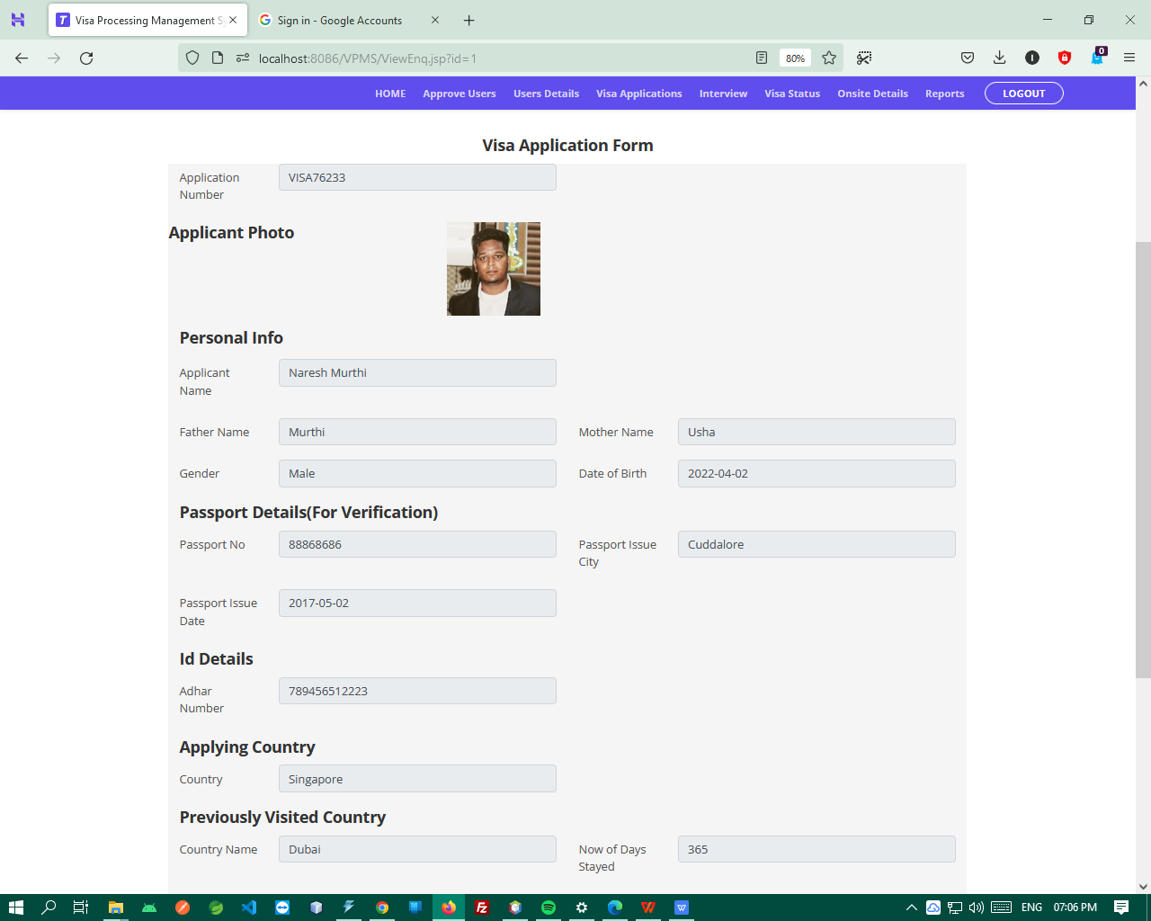

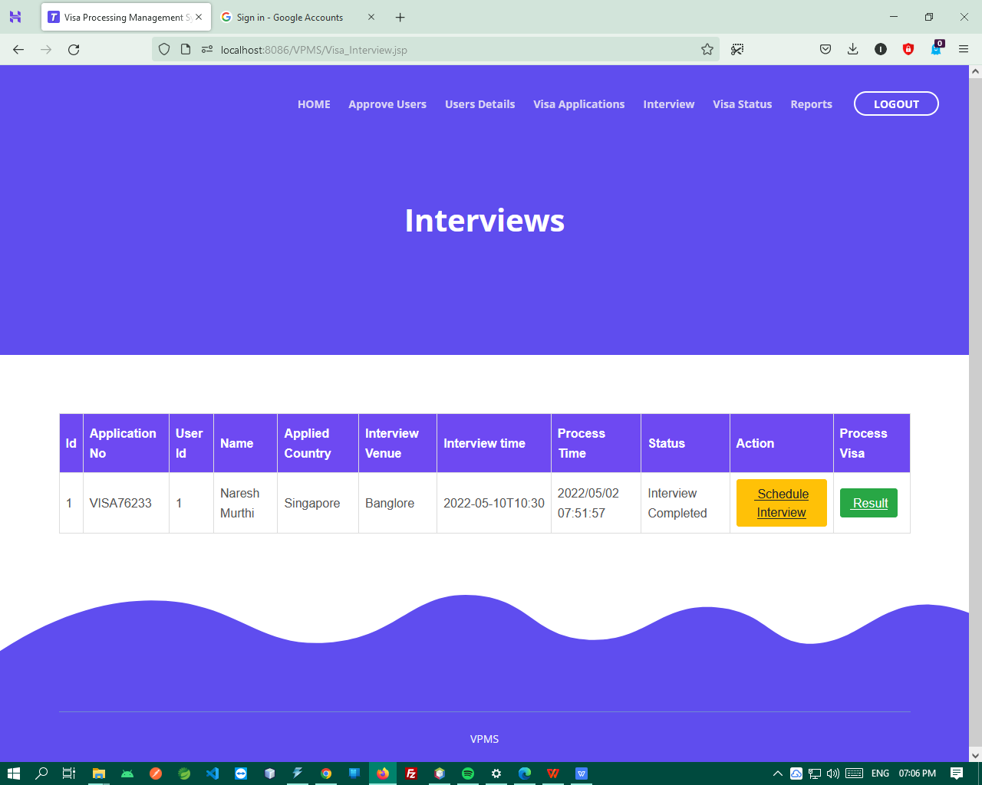

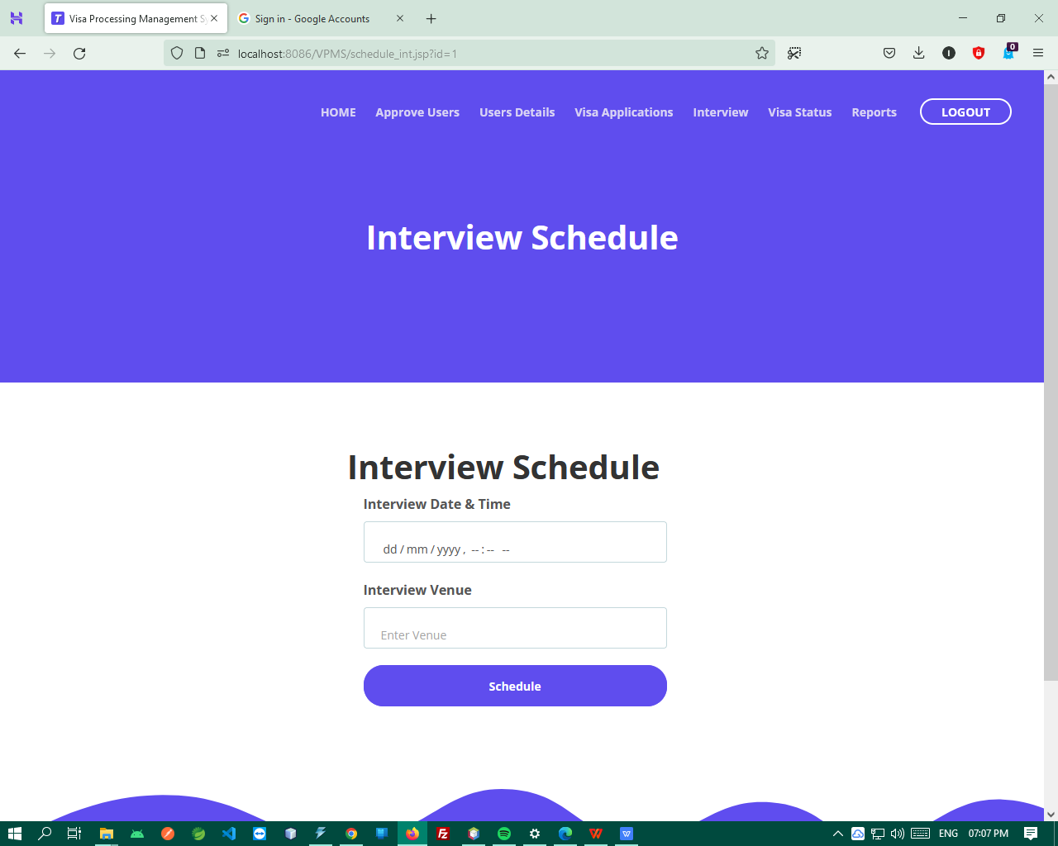

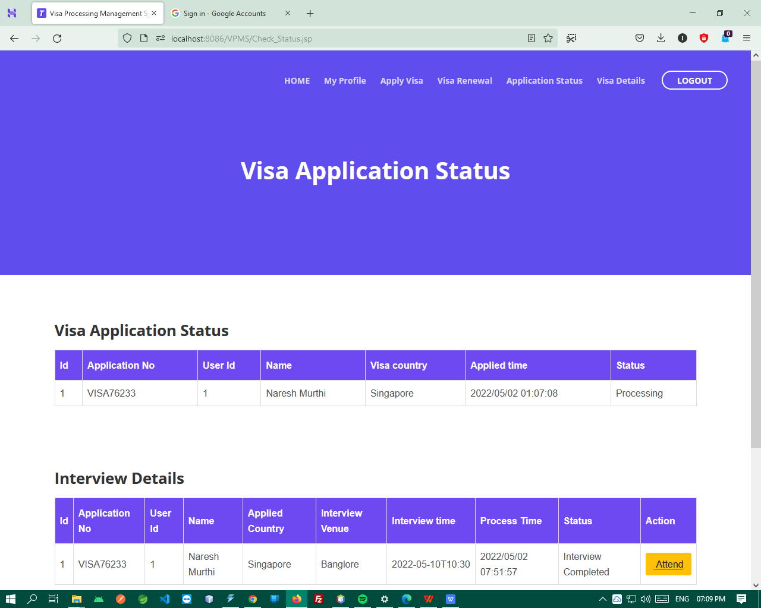

4.4 FEASIBILITY STUDY

The feasibility of the project is analyzed in this phase and business proposal is put forth with a very general plan for the project and some cost estimates. During system analysis the feasibility study of the proposed system is to be carried out. This is to ensure that the proposed system is not a burden to the company. For feasibility analysis, some understanding of the major requirements for the system is essential.

Three key considerations involved in the feasibility analysis are

- ECONOMICAL FEASIBILITY
- TECHNICAL FEASIBILITY
- SOCIAL FEASIBILITY

ECONOMICAL FEASIBILITY

This study is carried out to check the economic impact that the system will have on the organization. The amount of fund that the company can pour into the research and development of the system is limited. The expenditures must be justified. Thus the developed system as well within the budget and this was achieved because most of the technologies used are freely available. Only the customized products had to be purchased.

TECHNICAL FEASIBILITY

This study is carried out to check the technical feasibility, that is, the technical requirements of the system. Any system developed must not have a high demand on the available technical resources. This will lead to high demands on the available technical resources. This will lead to high demands being placed on the client. The developed system must have a modest requirement, as only minimal or null changes are required for implementing this system.

SOCIAL FEASIBILITY

The aspect of study is to check the level of acceptance of the system by the user. This includes the process of training the user to use the system efficiently. The user must not feel threatened by the system, instead must accept it as a necessity. The level of acceptance by the users solely depends on the methods that are employed to educate the user about the system and to make him familiar with it. His level of confidence must be raised so that he is also able to make some constructive criticism, which is welcomed, as he is the final user of the system.

School of Computer Engineering, KIIT, BBSR 14

Chapter 5

INPUT DESIGN AND OUTPUT DESIGN

INPUT DESIGN
The input design is the link between the information system and the user. It comprises the developing specification and procedures for data preparation and those steps are necessary to put transaction data in to a usable form for processing can be achieved by inspecting the computer to read data from a written or printed document or it can occur by having people keying the data directly into the system. The design of input focuses on controlling the amount of input required, controlling the errors, avoiding delay, avoiding extra steps and keeping the process simple. The input is designed in such a way so that it provides security and ease of use with retaining the privacy. Input Design considered the following things:
- What data should be given as input?
- How the data should be arranged or coded?
- The dialog to guide the operating personnel in providing input.
- Methods for preparing input validations and steps to follow when error occur.

OBJECTIVES

1. Input Design is the process of converting a user-oriented description of the input into a computer-based system. This design is important to avoid errors in the data input process and show the correct direction to the management for getting correct information from the computerized system.

2. It is achieved by creating user-friendly screens for the data entry to handle large volume of data. The goal of designing input is to make data entry easier and to be free from errors. The data entry screen is designed in such a way that all the data manipulates can be performed. It also provides record viewing facilities.
3. When the data is entered it will check for its validity. Data can be entered with the help of screens. Appropriate messages are provided as when needed so that the user will not be in maize of instant. Thus the objective of input design is to create an input layout that is easy to follow

OUTPUT DESIGN
A quality output is one, which meets the requirements of the end user and presents the information clearly. In any system results of processing are communicated to the users and to other system through outputs. In output design it is determined how the information is to be displaced for immediate need and also the hard copy output. It is the most important and direct source information to the user. Efficient and intelligent output design improves the system’s relationship to help user decision-making.
1. Designing computer output should proceed in an organized, well thought out manner; the right output must be developed while ensuring that each output element is designed so that people will find the system can use easily and effectively. When analysis design computer output, they should Identify the specific output that is needed to meet the requirements.
2. Select methods for presenting information.
3. Create document, report, or other formats that contain information produced by the system.
The output form of an information system should accomplish one or more of the following objectives.
- Convey information about past activities, current status or projections of the
- Future.
- Signal important events, opportunities, problems, or warnings.
- Trigger an action.
- Confirm an action

Chapter 6

Conclusion and Future Scope

6.1 Conclusion

The Visa Processing Information System is a web-based application for tracking the visa transactions in a visa processing company which provide customized solutions to meet company/customer needs. This application software has been computed successfully and was also tested successfully by taking “test cases”. It is user friendly, and has required options, which can be utilized by the user to perform the desired operations. The software is developed using Java as front end and MySQL as back end in Windows environment.
The goals that are achieved by the software are:
- Instant access.
- Improved productivity.
- Optimum utilization of resources.
- Efficient management of records.
- Simplification of the operations.
- Less processing time and getting required information.
- User friendly.
- Portable and flexible for further enhancement.

6.2 Future Scope

The future work can be considered developing a Mobile App which will be suitable for any Mobile application so it will be making the processing of Visa System more portable for both applicant and the others

School of Computer Engineering, KIIT, BBSR

Online Car Parking Booking System

References

[1]. Ramandeep Kaur –Aman Arora, “Configuration Management: A Review” International Journal of Advanced Research in Computer Science and Software Engineering Volume 2013

[2]. Mark Lindeman, Philip B.Stark, “A Gentle Introduction to Risk –limiting Audits” IEEE 2012

[3]. Yongchang Ren, Tao Xing, Qiang Quan, “Software Configuration Management of Version Control Study Based on Baseline” IEEE 2010

[4]. Mark Staples,Paul L Bannerman,”Software Configuration Management in Global Software Development: A Systematic Map” IEEE 2010

[5]. Tao Xing “Software Configuration Management of Change Control Study Based on Baseline” IEEE 2010

[6]. Bo Yang, “Knowledge-Enhanced Change Audit for Configuration Management” IEEE 2010

[7]. Steven M.Bellovin,Randy Bush “Configuration Management and Security” IEEE 2009

School of Computer Engineering, KIIT, BBSR

Aniket Kumar Mishra
2029187

- Individual contribution and findings:I took on the database implementation, which included setting up the MySQL database, creating tables, and creating associations. In order to guarantee data integrity and maximise storage, I also applied normalisation techniques to the database architecture. These efforts made sure that the database structure for the Online Visa Management System was efficient and effective.

- Individual contribution to project report preparation: My contributions to the report included ensuring that the standards section adhered to industry best practises. This included creating coding and design guidelines that encourage the best possible code organisation, naming patterns, commenting, and documentation. Optimising code performance and maintainability was prioritised. In the system design and architecture section, I also made a contribution that described the general organisation of the system, including component identification, interaction, and data flow.



Full Signature of Supervisor: Full signature of the student:
……………………………. ……………………………..

Ujjwal Singh
2029193

- Individual contribution and findings: I actively participated in gathering requirements, which included learning about the objectives of the project and getting feedback from stakeholders. Additionally, I worked on the system's back-end development using the Java programming language, which led to the creation of a reliable and effective server-side logic for the Online Visa Management System.

- Individual contribution to project report preparation: My involvement in the study included helping to develop the software requirements specification (SRS) and resolving the report's issue statement. Through the articulation of the existing challenges and their identification, the project scope was clearly understood. The SRS document provided the development team with a well-organized and documented project by outlining features like Slot Booking, Time-Specific Slot Management, and Slot Availability for the website. In order to gain a solid knowledge of the project's core concepts, relevant research materials were also carefully evaluated to discover approaches and instruments utilised in similar studies. These contributions were extremely important in determining the project's strategy and results.



Full Signature of Supervisor: Full signature of the student:
……………………………. ……………………………..

Abdul Wahid Aadil
2029194

- Individual contribution and findings:I used the Java programming language to complete the back-end development process, which included creating the server-side logic. To manage user requests and process data, the required business logic and algorithms were put into place. I also worked on the system's database design, using normalisation techniques to guarantee data integrity and get rid of duplication. Effective data storage and retrieval were accomplished by effectively organising the database tables and creating relevant linkages. A reliable and effective Online Visa Management System was produced as a consequence of the contributions made throughout the back-end development and database design phases.

- Individual contribution to project report preparation: I provided a lot of contributions to the report's introduction and fundamental concepts parts. The importance of the initiative was emphasised, and the opening provided a summary of the report. The methodologies and tools employed in related studies were identified for the section on fundamental ideas after a thorough examination of pertinent research materials. My contributions helped the project's approach and results, laying a solid groundwork for the investigation.



Full Signature of Supervisor: Full signature of the student:
……………………………. ……………………………..

Ankit Dev
2029195

- Individual contribution and findings: I created the user interface, database schema, and system architecture during the system design phase. The user interface design was made to be simple and easy to use. The database's organisational and functional goals guided its design. The overall system design was established to guarantee efficient operation and component integration. In order to develop an aesthetically pleasing and responsive design, CSS and HTML were also used to construct the user interface. The functioning and look of the Online Visa Management System were greatly influenced by these contributions.

- Individual contribution to project report preparation:I gave input to the report's methodology/proposal, outcome analysis, and quality parts. The methodology/proposal part provided a clear idea of the project's completion by outlining the steps and procedures required to develop various website components. The aspect of quality assurance was also covered, making sure that procedures were followed during the planning and execution of the project. A visual picture was given by including screenshots of several website sections.



Full Signature of Supervisor: Full signature of the student:
……………………………. ……………………………..

Abhinav Prakash
2029042

- Individual contribution and findings:I spearheaded the development of an Online Visa Management System system, utilizing Java for robust back-end development. This involved crafting server-side logic, implementing business logic, and employing algorithms to manage user requests and process data. I played a pivotal role in the system's database design, ensuring data integrity through normalization techniques and optimizing data storage. Actively engaged in requirements gathering, I aligned project objectives and stakeholder feedback. The culmination of these efforts resulted in the successful creation of a dependable and efficient Online Visa Management System, seamlessly integrating back-end development, and database design for a comprehensive solution.

- Individual contribution to project report preparation: I provided a lot of contributions to the report's introduction and fundamental concepts parts. The importance of the initiative was emphasised, and the opening provided a summary of the report. The methodologies and tools employed in related studies were identified for the section on fundamental ideas after a thorough examination of pertinent research materials. My contributions helped the project's approach and results, laying a solid groundwork for the investigation.


Full Signature of Supervisor: Full signature of the student:
……………………………. ……………………………..

Siddharth
2029214

- Individual contribution and findings:
In the system design phase, I orchestrated the creation of an intuitive user interface, a well-structured database schema, and an efficient system architecture. Emphasizing simplicity and usability, the user interface was crafted using CSS and HTML. The database implementation involved MySQL setup, table creation, and association establishment, with a focus on data integrity through normalization techniques. These meticulous contributions resulted in an aesthetically pleasing, responsive design, influencing both the functionality and appearance of the Online Visa Management System. The database structure reflects efficiency and effectiveness, ensuring seamless operation and optimized storage.

- Individual contribution to project report preparation: I made significant contributions to the report's introduction and sections on basic ideas. The beginning included an overview of the report and underlined the significance of the project. After a careful review of relevant research resources, the procedures and instruments used in related investigations were selected for the section on basic ideas. My efforts improved the project's methodology and outcomes and established a strong foundation for the study.



Full Signature of Supervisor: Full signature of the student:
……………………………. ……………………………..

School of Computer Engineering, KIIT, BBSR

TURNITIN PLAGIARISM REPORT
(This report is mandatory for all the projects and plagiarism
must be below 25%)

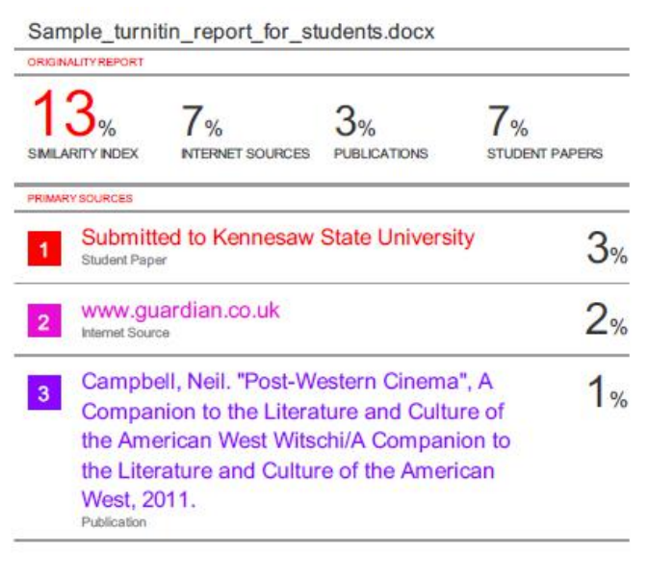

School of Computer Engineering, KIIT, BBSR

